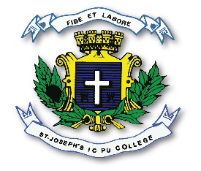
ST. JOSEPH’S INDIAN COMPOSITE PU COLLEGE
#23, Vittal Mallya Road, Bangalore – 560001.

SUBJECT: PHYSICS (33)
I PUC
SYLLABUS FOR I TEST – 2023-24

Chapters -
1. Units and Measurements.
2. Motion in a Straight Line.
3. Motion in a Plane.
4. Laws of motion.

